Year 6

**Computing Curriculum Map**

**Video, Images and Animation**

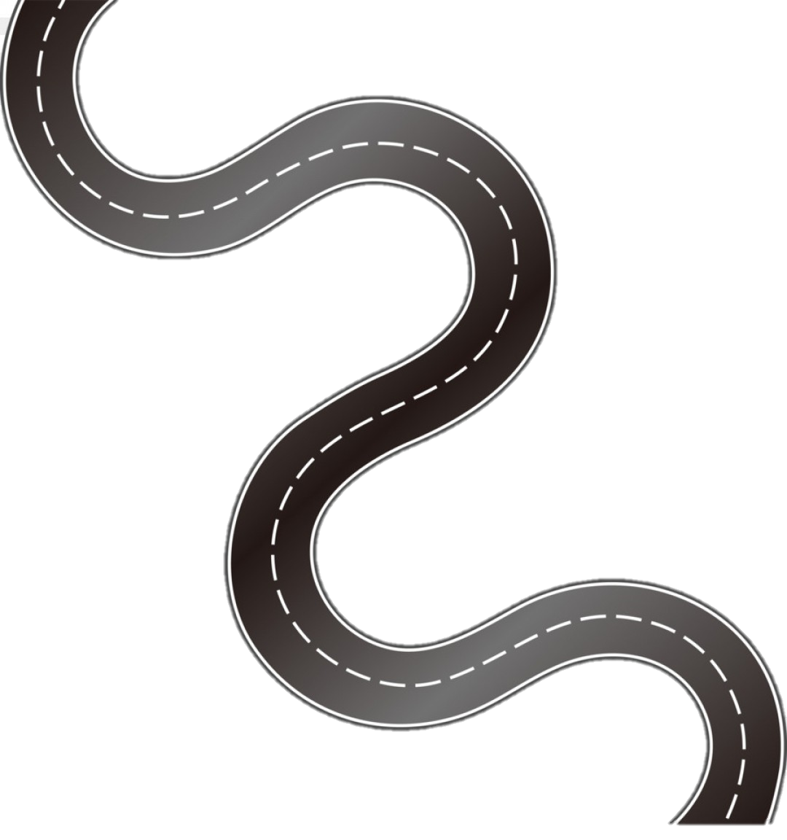

**EYFS**



**KS 1**



**Lower**

**KS2**

**Upper KS2**

cv

Year 5

Year 3

▪ Use a range of devices to capture still and moving images for a purpose.

▪ Be able to use basic tools in a software package to change images according to purpose.

▪ Begin to understand how images from different sources are used to enhance a presentation or communicate an idea.

Year 1 -

Year 4

▪ Acquire, store and retrieve images from camera for a purpose.

▪ Be able to resize various elements in a graphics or paint package.

▪ Be able to resize images

▪ Storyboard, then use captured images to create a short animated sequence which communicates a specific idea.

EYFS

Children recognise that a range of technology is used in places such as homes and schools. They select and use technology for particular purposes.

Year 2

v