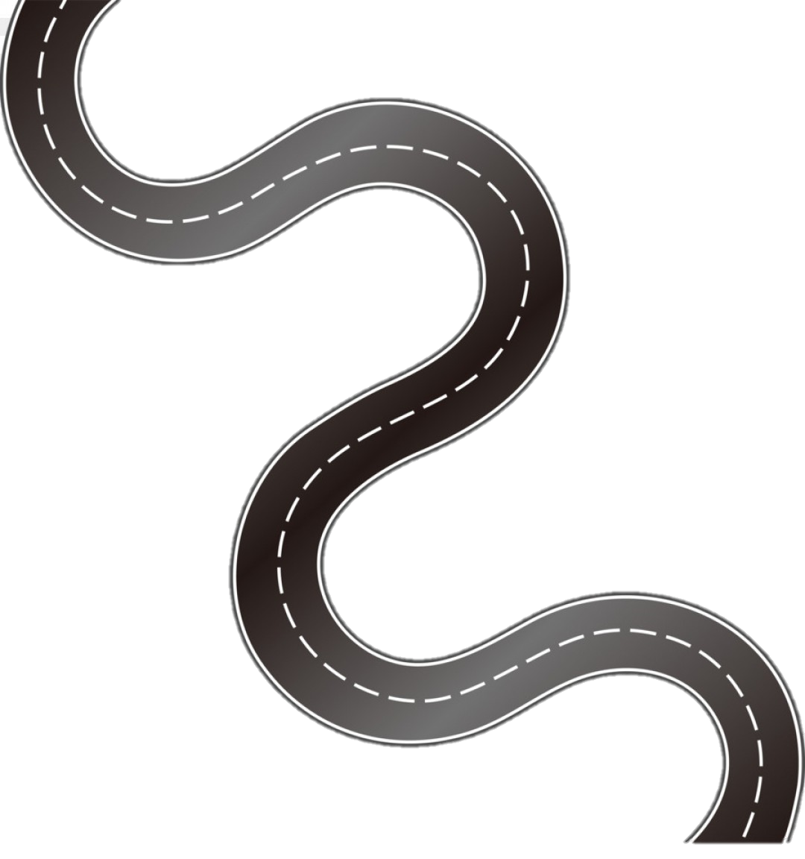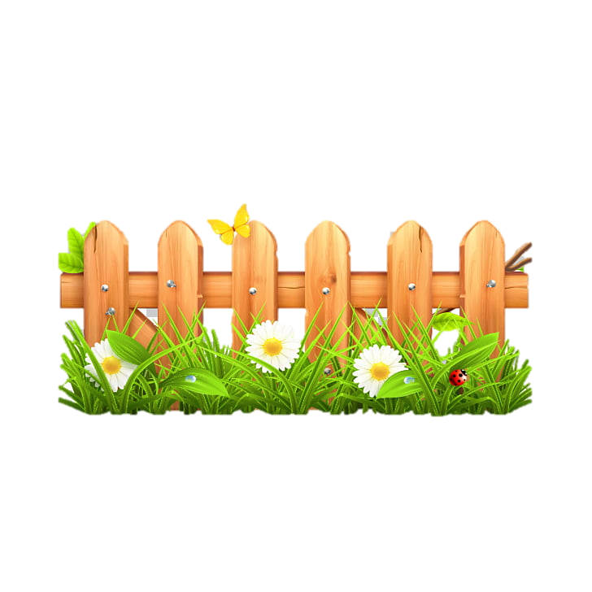

**Subject Curriculum Map**

**Maths – Decimals**

**(Recognise, write, compare and calculate)**

Year 6

* Read, write, order and compare numbers up to 10,000,000 and determine the value of each digit.

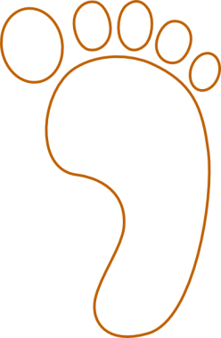cv

Year 1

Year 6

* Identify the value of each digit in numbers given to three decimal places.
* Multiply and divide numbers by 10, 100 and 1000 giving answers up to three decimal places.
* Multiply one digit numbers with up to two decimal places by whole numbers.
* Use written division methods, in cases where the answer has up to two decimal places.
* Solve problems which require answers to be rounded to specified degrees of accuracy.

Year 3

Year 4

* Recognise and write decimal equivalents of any numbers of tenths or hundredths.
* Recognise and write decimal equivalents to ¼ ½ ¾
* Round decimals with one decimal place to the nearest whole number.
* Compare numbers with the same number of decimal places, up to two decimal places.
* Find the effect of dividing a one or two digit number by 10 or 100, identifying the value of the digits in the answer as ones, tenths and hundredths.

Year 5

* Read and write decimal numbers as fractions (for example, 0.71 = 71/100)
* Recognise and use thousandths and relate them to tenths, hundredths and decimal equivalents.
* Round decimals with two decimal places to the nearest whole number and to one decimal place.
* Read, write, order and compare numbers with up to three decimal places.
* Solve problems involving number up to three decimal places.

Year 2

**Upper KS2**

EYFS -

**Lower**

**KS2**

**KS 1**

**EYFS**

v