**Subject Curriculum Map**

**Maths – Fractions**

**(Recognise, write and compare)**

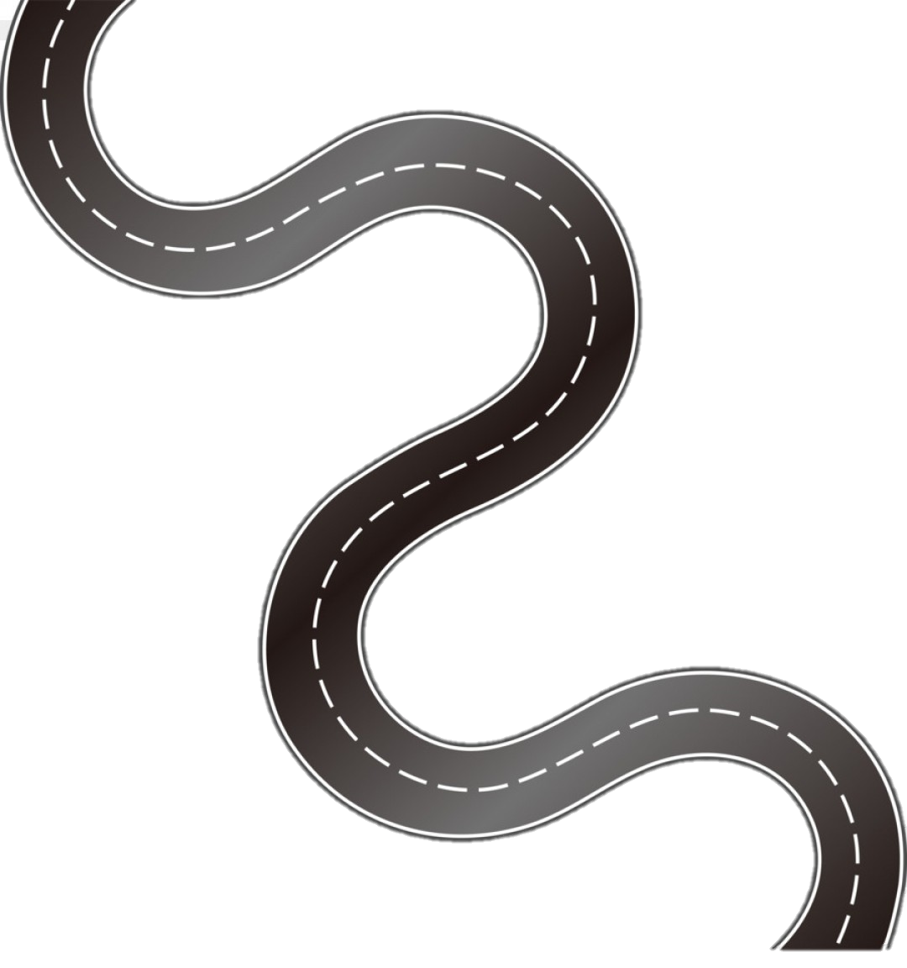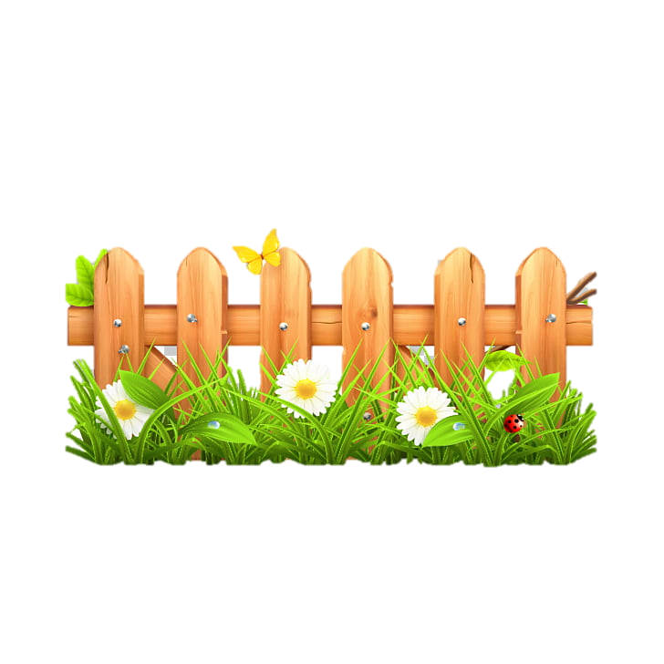

Year 6

* Read, write, order and compare numbers up to 10,000,000 and determine the value of each digit.

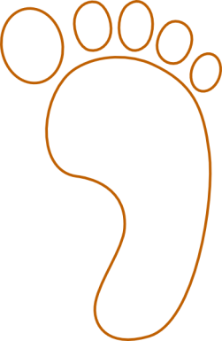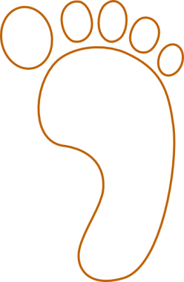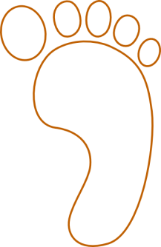cv

Year 5

* Identify, name and write equivalent fractions of a given fraction, represented visually, including tenths and hundredths.
* Recognise mixed numbers and improper fractions and convert from one form to the other and write mathematical statements > 1 as a mixed number (for example, 2/5 + 4/5 = 6/5 = 1 1/5)
* Compare and order fractions whose denominators are all multiples of the same number.

Year 3

* Count up or down in tenths; recognise that tenths arise from dividing an object into 10 equal parts and in dividing one digit numbers or quantities by 10.
* Recognise, find and write fractions of a discrete set of objects; unit fractions and non-unit fractions with small denominators.
* Recognise and use fractions as numbers: unit fractions and non-unit fractions with small denominators.
* Recognise and show, using diagrams, equivalent fractions with small denominators.
* Compare and order unit fractions, and fractions with the same denominators.

Year 6

* Use common factors to simplify fractions; use common multiples to express fractions in the same denomination.
* Compare and order fractions, including fractions > 1.

**Upper KS2**

Year 4

* Count up and down in hundredths; recognise that hundredths arise when dividing an object by one hundred and dividing tenths by ten.
* Recognise and show, using diagrams, families of common equivalent fractions.

Year 2

* Recognise, find, name and write fractions 1/3 ¼ 2/4 and ¾ of a length, shape, set of objects or quantity.
* Recognise the equivalence of ½ and 2/4.

Year 1

* Recognise, find and name a half as one of two equal parts of an object, shape or quantity.
* Recognise, find and name a quarter as one of four equal parts of an object, shape or quantity.

EYFS -

**Lower**

**KS2**

**KS 1**

**EYFS**

v