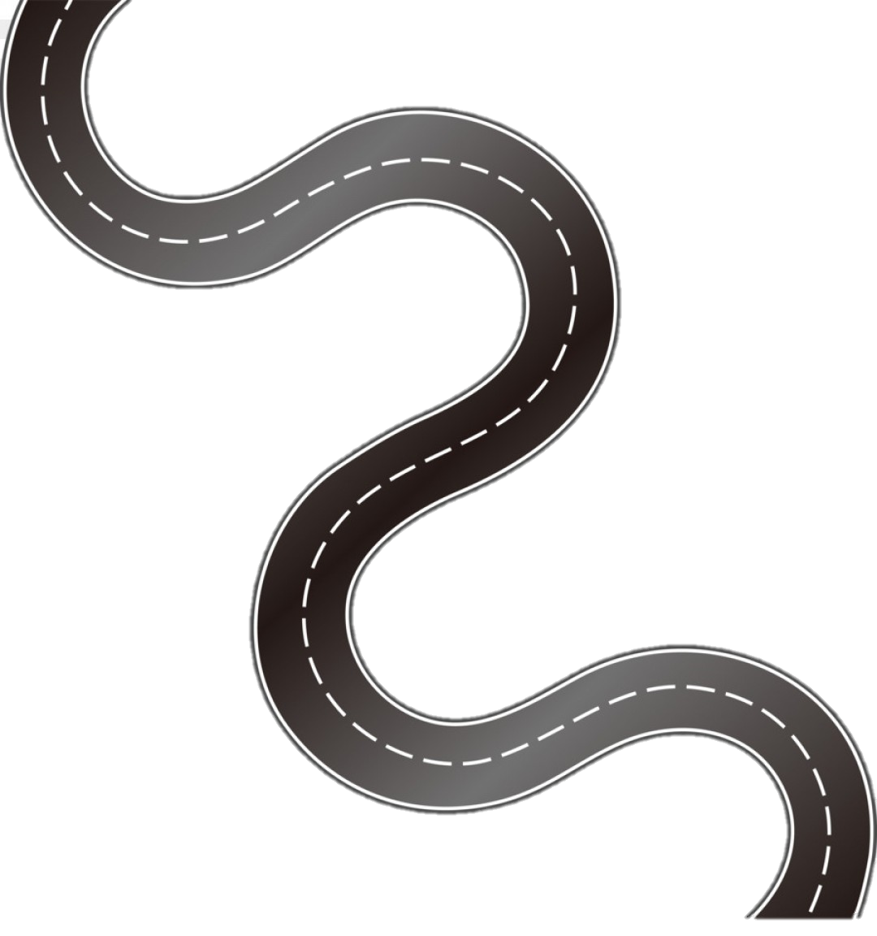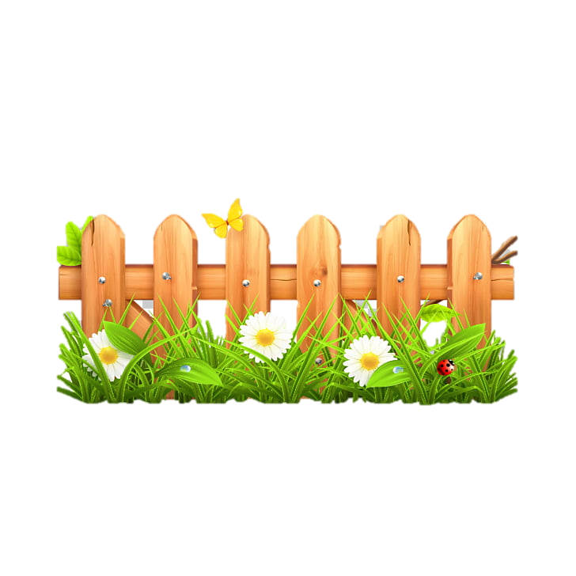

**Subject Curriculum Map**

**Maths – Geometry**

**(Position and Direction)**

Year 6

* Read, write, order and compare numbers up to 10,000,000 and determine the value of each digit.

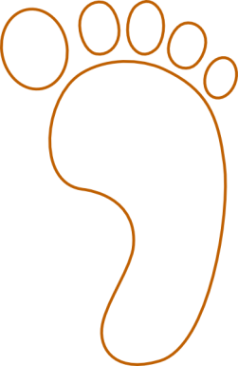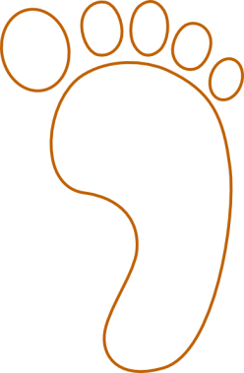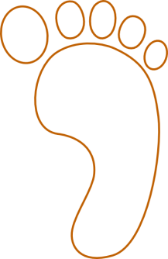cv

EYFS -

* Continue and create own simple repeating patterns. (e.g. AB and ABC patterns).

Year 4

* Describe positions on a 2D grid as coordinates in the first quadrant.
* Describe movements between positions and translations of a given unit to the left/right and up/down.
* Plot specified points and draw sides to complete a given polygon.

Year 3

Year 6

* Describe positions on the full coordinate grid (all four quadrants)
* Draw and translate simple shapes on the coordinate plane, and reflect them in the axes.

Year 5

* Identify, describe and represent the position of a shape following a reflection or translation, using the appropriate language, and know that the shape has not changed.

Year 2

* Order and arrange combinations of mathematical objects in patterns and sequences.
* Use mathematical vocabulary to describe position, direction and movement, including movement in a straight line and distinguishing between rotation as a turn and in terms of right angles for quarter, half and three quarter turns (clockwise and anti-clockwise).

Year 1

* Describe position, direction and movement, including half, quarter and three quarter turns.

**Upper KS2**

**Lower**

**KS2**

**KS 1**

**EYFS**

v