**Subject Curriculum Map**

**Maths – Measurement**

**(Using measures)**

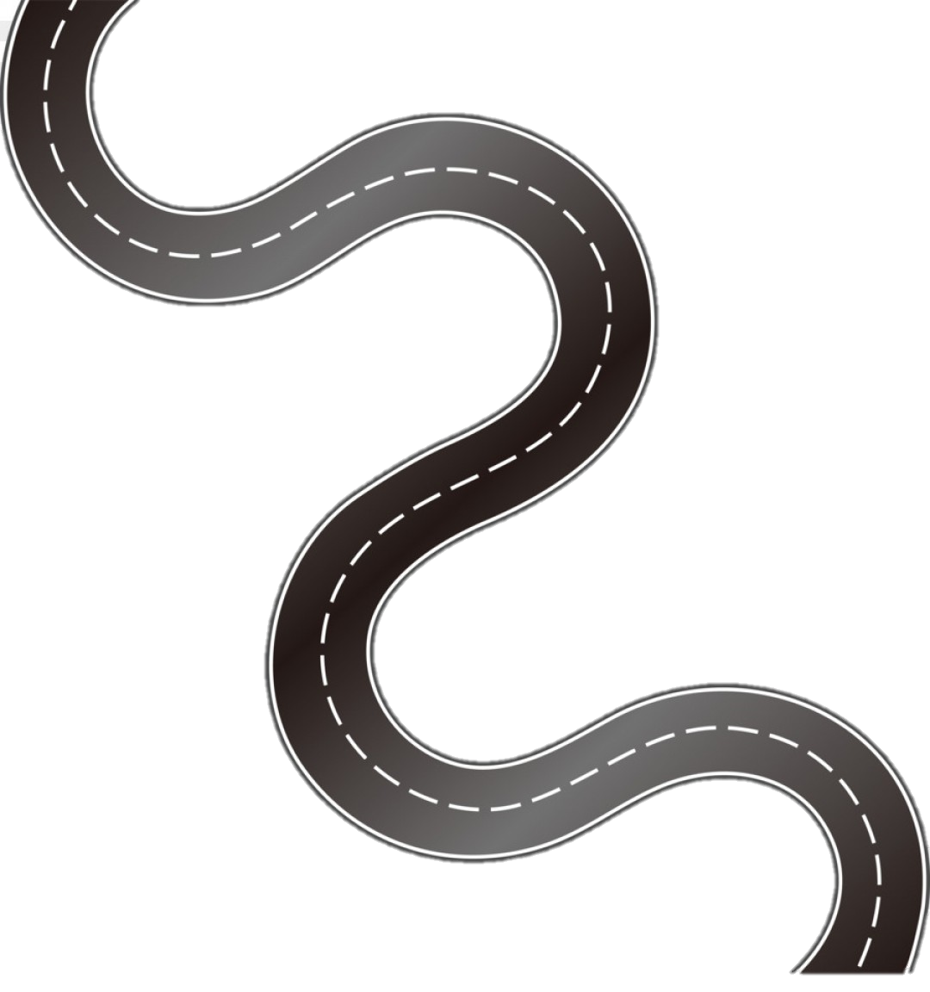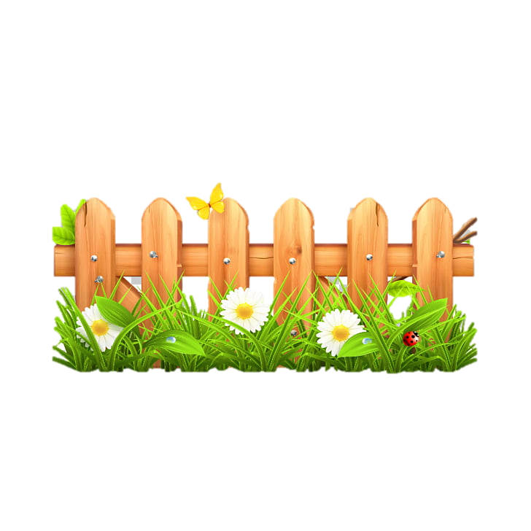

Year 6

* Read, write, order and compare numbers up to 10,000,000 and determine the value of each digit.

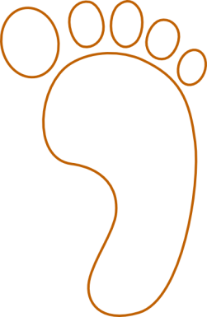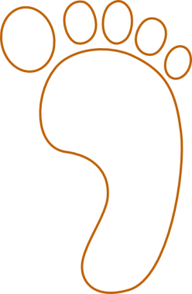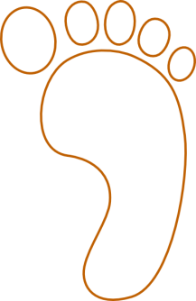cv

EYFS -

* Use language to describe length and height. (e.g. the tree is tall, the pencil is short).
* Compare the weight of objects using the language heavy, heavier, heaviest and light, lighter, lightest.
* Compare the capacity of containers using different materials (e.g. sand, water, rice).

Year 6

* Solve problems involving the calculation and conversion of units of measure, using decimal notation up to three decimal places where appropriate.
* Use, read, write and convert between standard units, converting measurements of length, mass, volume and time from a smaller unit of measure to a larger unit, and vice versa, using decimal notation to up to three decimal places.
* Convert between miles and kilometres.

**Upper KS2**

Year 5

* Convert between different units of metric measure (for example, kilometre and metre; centimetre and metre; centimetre and millimetre; gram and kilogram; litre and millilitre).
* Understand and use approximate equivalences between metric units and common imperial units such as inches, pounds and pints.
* Use all four operations to solve problems involving measure using decimal notation, including scaling.

Year 4

* Convert between different units of measure (for example, kilometre to metre; hour to minute).
* Estimate, compare and calculate different measures.

Year 3

* Measure, compare, add and subtract lengths (m/cm/mm); mass (kg/g); volume/capacity (l/ml).

Year 2

* Choose and use appropriate standard units to estimate and measure length/ height in any direction (m/cm); mass (kg/g); temperature (oC); capacity (litres/ml) to the nearest appropriate unit, using rules, scales, thermometers and measuring vessels.
* Compare and order lengths, mass, volume/capacity and record the results using < > and =.

Year 1

* Compare, describe and solve practical problems for

- lengths and heights

- mass/weight

- capacity and volume

- time

* Measure and begin to record the following:

- lengths and heights

- mass/weight

- capacity and volume

- time (hours, minutes, seconds)

**Lower**

**KS2**

**KS 1**

**EYFS**

v